**ReconInsight**

**Shapefiles tutorial**

**August 2017**

**Abstract**

The RI360 map module makes it possible to visualize your data over a geographic region. This type of data visualization is called geospatial analytics. The new map module offers hundreds of geographic maps to choose from and a variety of ways to manipulate the data over these maps.

The RI360 map module incorporates two different map types. The first map type is an SVG map. This map type is static meaning you are limited to the amount of interaction you can have with the map. The second type is a Slippy map. This map type allows the user to interact with the map in numerous ways. Fist the slippy map allows the user to move around the map by simply clicking and dragging. The map also allows for the user to zoom in and out of geographic regions.

The two map types are capable of most of the same geospatial analytics. The map module is capable of creating a summarized by area map which is a map that has regions colored based on a distinct value. For example, a map of the United States colored red or blue will help show divide between which states are democrat vs republican. The summarized by area map offers the ability to have two distinct color schemes going on at once. This is great for showing things like net revenue or positive and negative scales. The map module is also able to plot individual points on a map. We refer to this type of map as a discrete map. Discrete maps give the user the option to let their data customize each point. For example, the points on a map have the ability to grow and shrink in size depending on the data that is passed to it. We call the varying discrete points size as its magnitude. The points on the map can also be color coded in case there is a type of category of data that you are trying to display. For slippy maps only, we have the ability to form a continuous map also known as a heat map. This map is good for maps that are really dense and have thousands of data points. The map module is built to handle multiple sets of data at once. The module allows for multiple discrete data sets, which is essential if the user is trying to show multiple sets of data. The module also allows for summarized by area maps to be mixed with discrete data points. The RI360 map module wants to offer the user as many customization options as possible.

The module is fully responsive when it comes to presenting the data. The map uses tool-tips to present the user with more data when they simply hover their mouse over different map features. For example, a discrete data point may have additional attributes so the tool-tip will allow the user to see this additional features. The tool tip can also be found on summarized by area maps where it will show you the value that is associated to a region’s coloring. Tool-tips can be found on both map types, SVG and Slippy maps. In addition to tool tips, Legends area also responsive in the sense that the user has the ability to move legends around the map module and add text to them. The module is clever enough to add different legends to the map depending on if the map is a summarized by area or discrete map.

In order for the RI360 map module to function properly, shapefiles need to be downloaded and converted into both geoJSON and topoJSON files. It is critical that these steps are done as follows so that the map module has some type of boundary region to refer to.

**Shapefiles**

**You can find shapefiles from a variety of different websites. The best website to download shapefiles for US specific regions is the census.gov website found below.**

1. Follow this link <https://www.census.gov/geo/maps-data/data/tiger.html> to a page that looks like the image below.

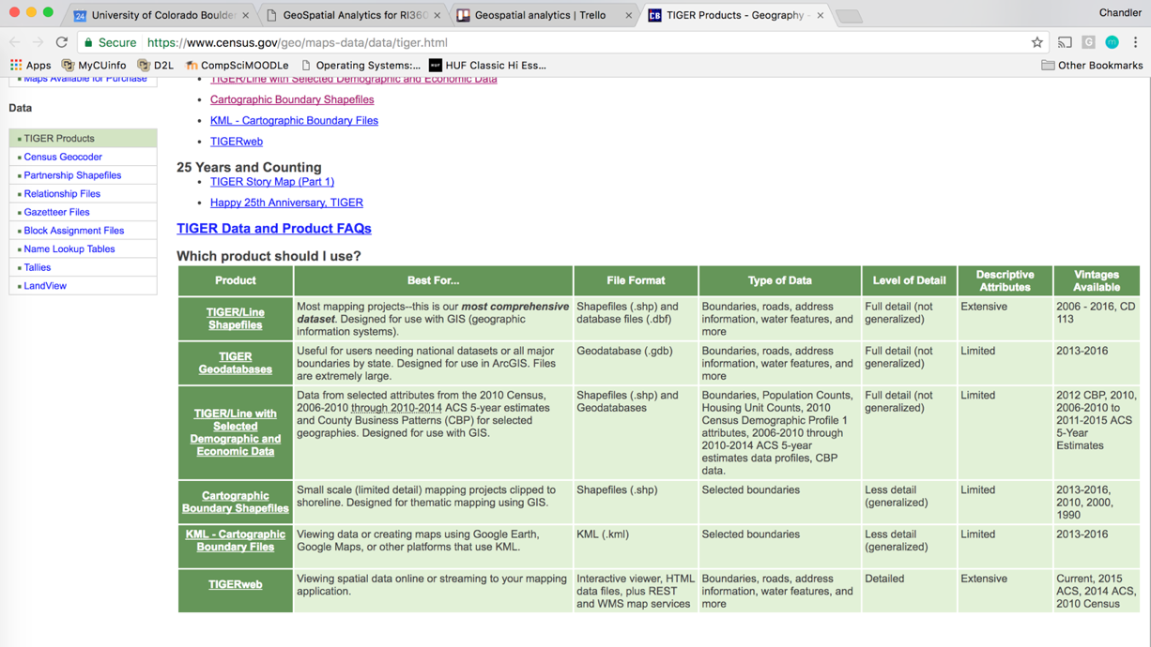

1. 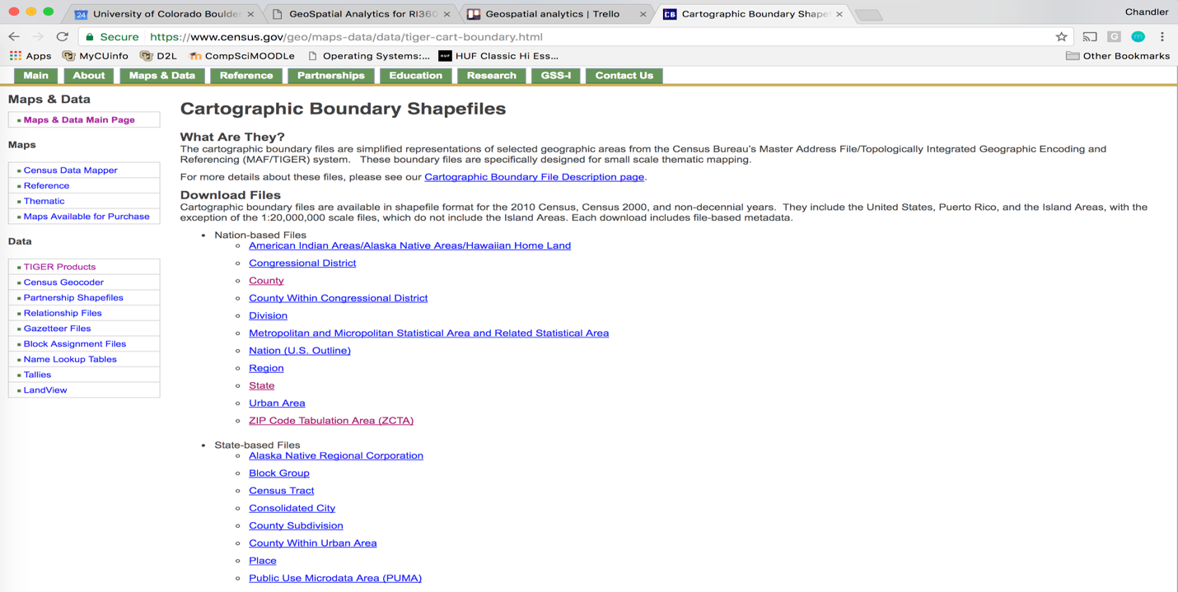Click on Cartographic Boundary Shapefiles
2. You are now presented with a large list of Nation and State based files to choose from.
3. Once you click on one Recommend to download 5m.zip

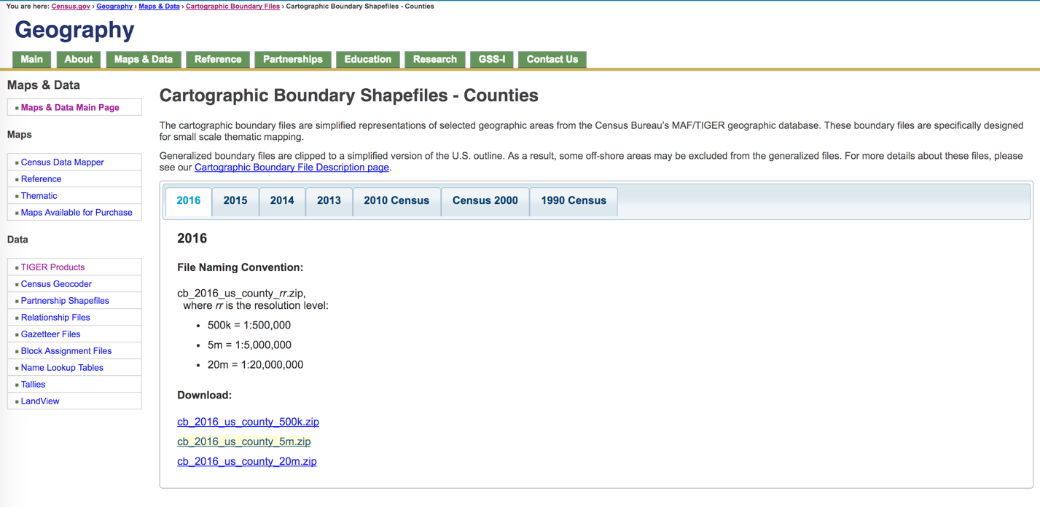

1. Open Terminal
2. Shp2geo <shapefile> -o <shapefile.geoJson>

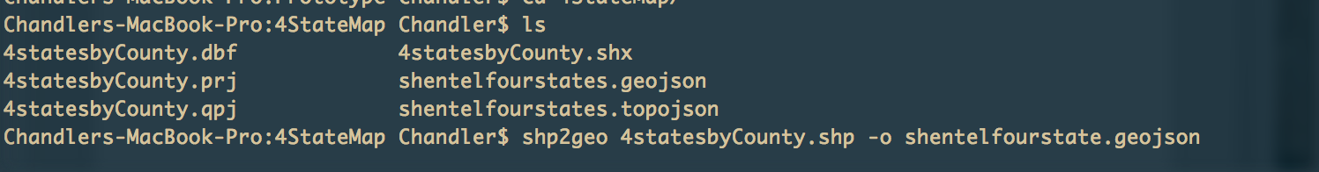

1. Geo2topo <shapefile.geojson> -o <shapefile.topojson>

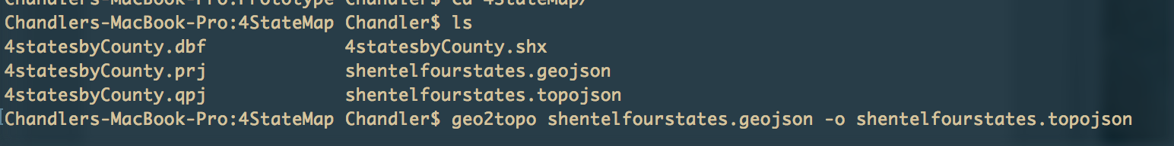

**QGIS Tutorial**

**QGIS is useful for selecting certain areas once you have a shapefile downloaded. For example, if you have a shapefile for the United States but you only want to select 3 or 4 states you would use QGIS to make a new shapefile containing only the selected states. This demonstration is using a map of the United States with counties. We are going to carve out California and turn the map into just California and counties inside.**

1. Once you complete steps 1 – 4 from above. Open Finder if mac or folder that contains your Zip file.

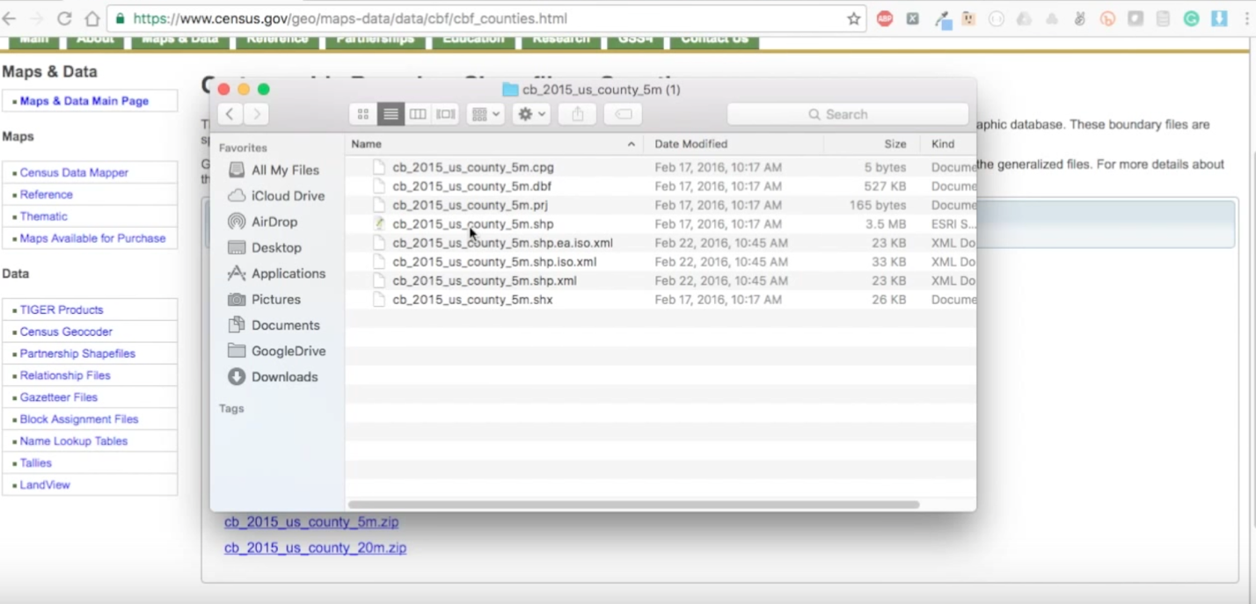

1. Double click on the .shp file that is included inside the Zip file
2. 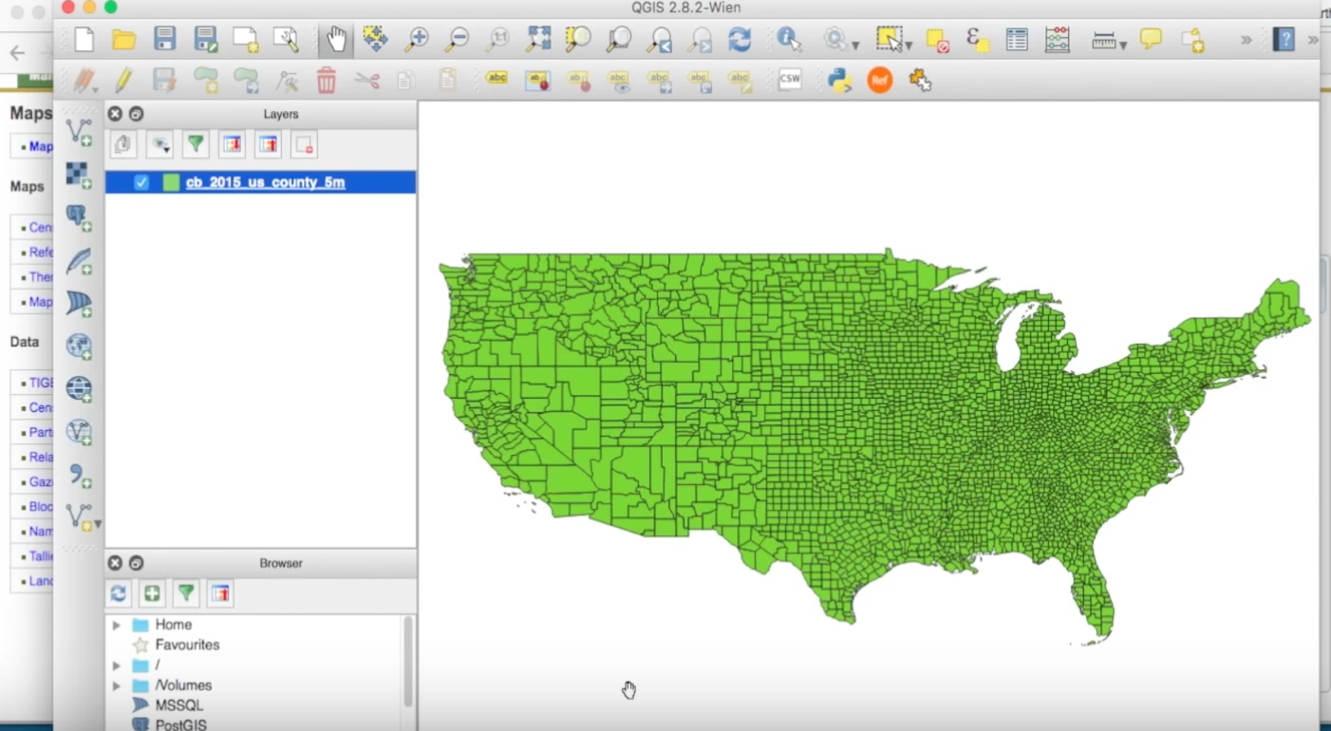QGIS should load the shapefile into the software and you should be presented with a map inside the GUI like this.
3. 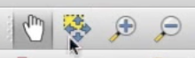Once the map loads you can use the zoom in(magnify glass with +) and zoom out(magnify glass with -) tool to help position your map. In addition, you can use choose the hand icon to help drag your map around.
4. Screen%20Shot%202017-08-11%20at%201.20.05%20PM.pngTo start carving out certain areas of the map, click on the expression tool that is located in the top right hand corner.
5. 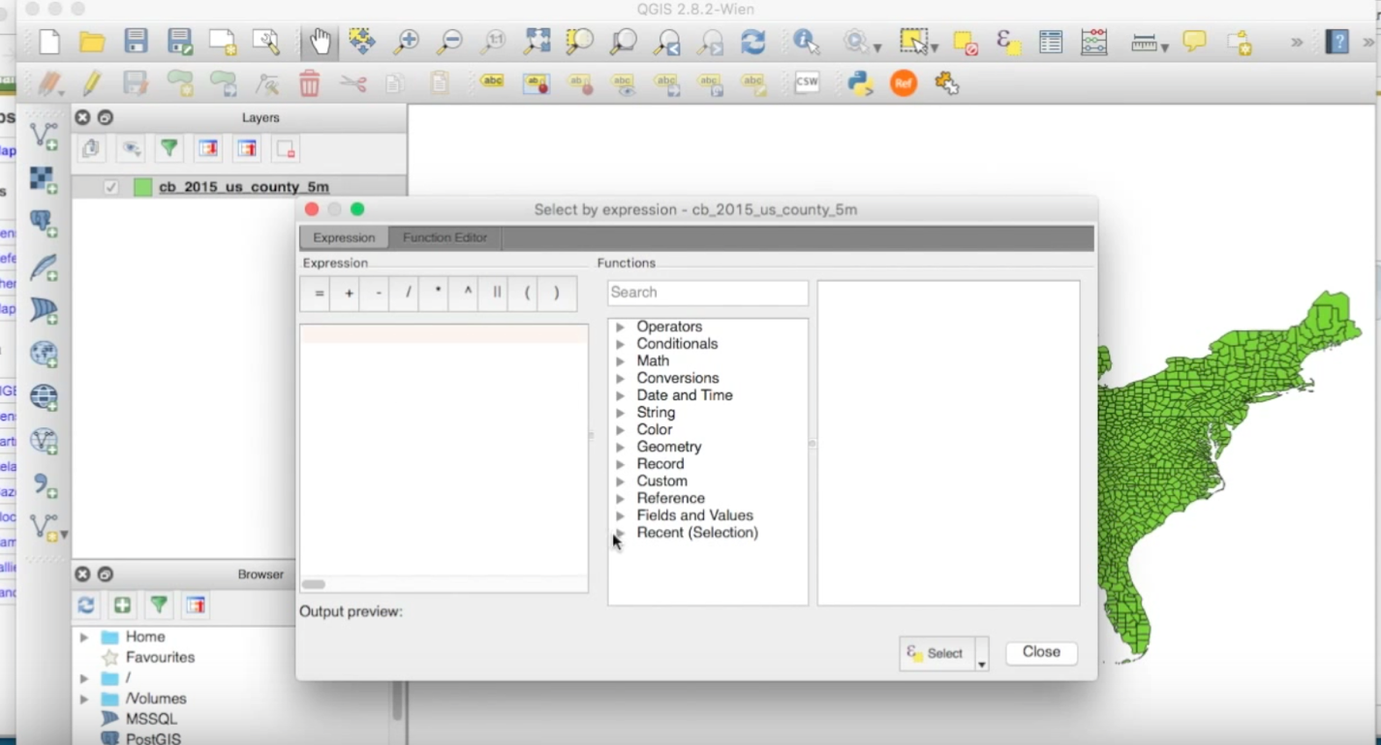Once you press this button you will be presented with a screen that looks like this.
6. 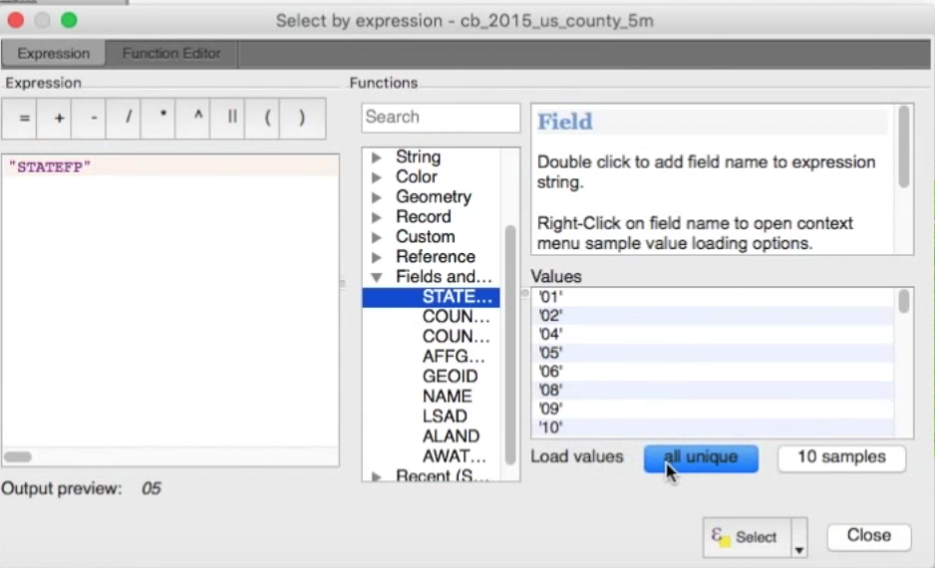Click on Fields and Values tab
7. You want to match the state you are trying to carve out with its FIPS code, so press STATEFP and click load the blue button at the bottom that says, “All unique”.
8. 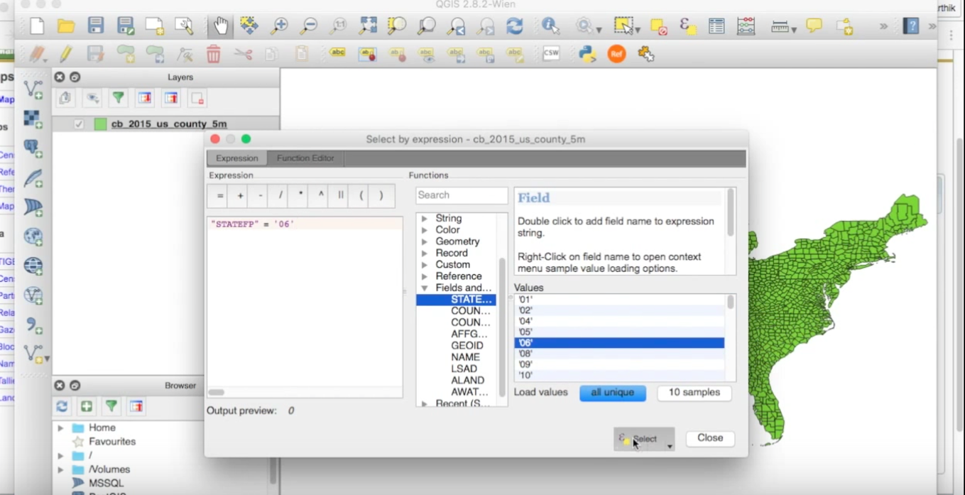First, click the equal sign in the top left corner… Then go to the loaded values and click on the FIPS code that represents your state. You can find a states FIPS code at this URL: http://www.columbia.edu/~sue/state-fips.html
9. Once the left window has a fields and values mark paired with an ID – press select and close.

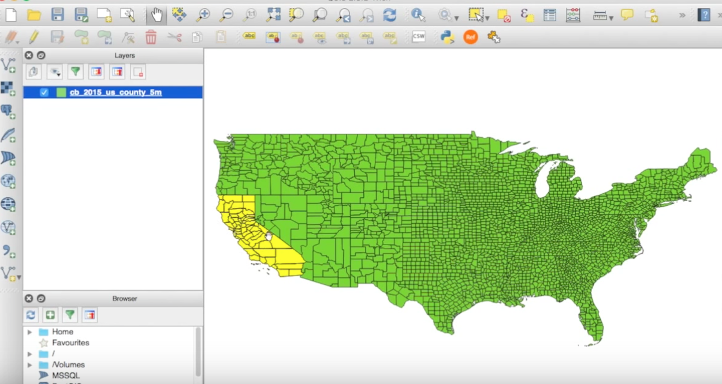

1. 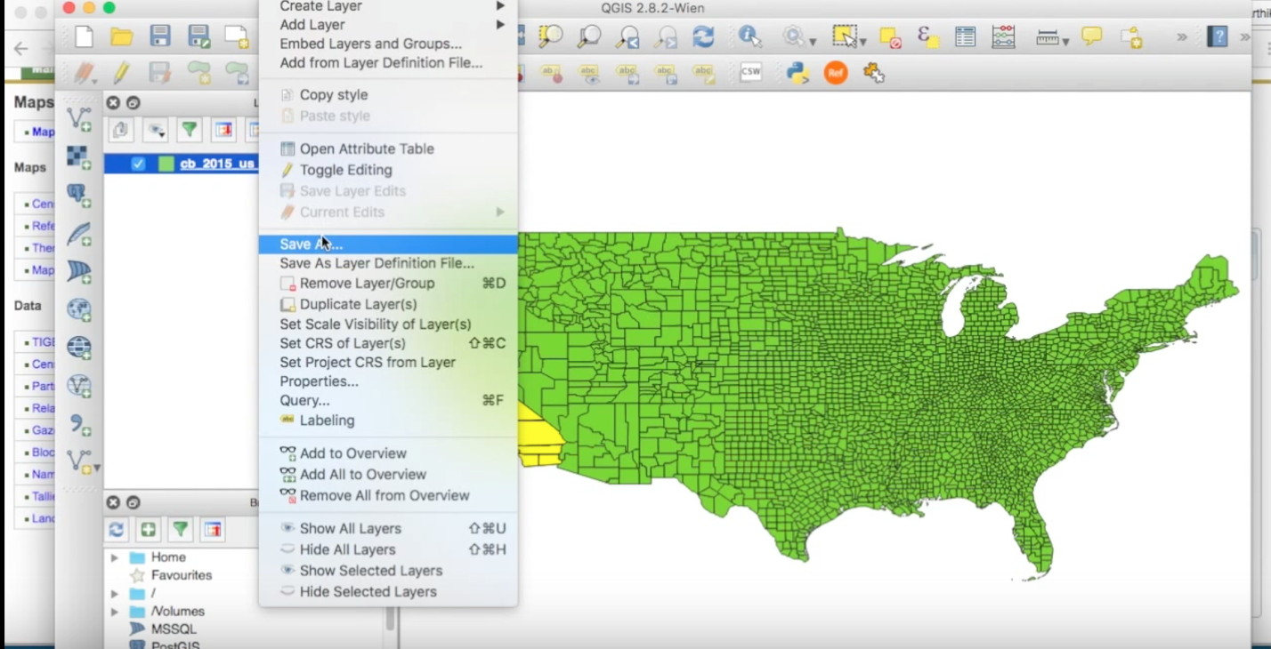Now that an area of the map is selected go to Layer > Save As…
2. 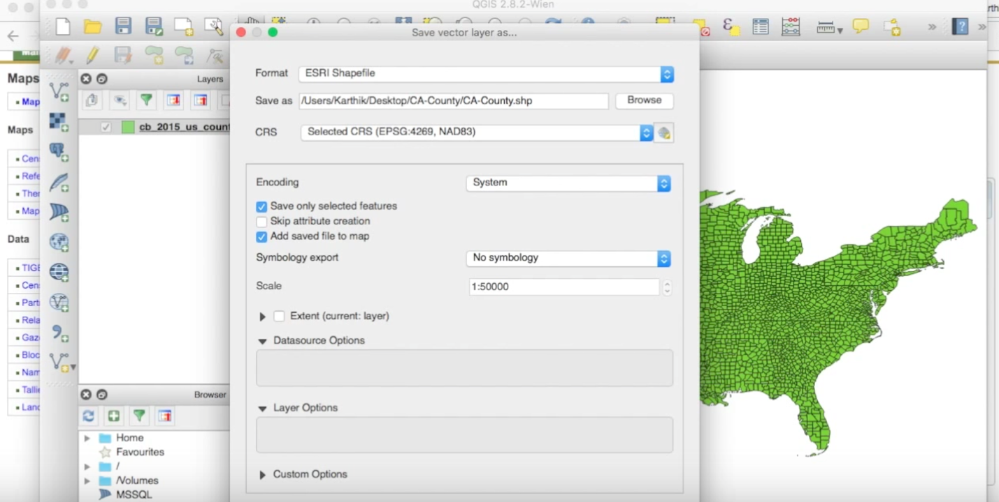Once you have the file path defined for where you want to save the new shape file. Check the “Save only the selected features”. This button is very important because we just selected a feature(california) and we want to make sure it gets carved out.
3. Once both boxes are checked press Okay at the bottom right hand corner.
4. You will be presented with the newly created shape file.
5. In order to turn that shapefile into a TopoJSON or GeoJSON object follow steps 5 – 7 in the Shapefiles tutorial.